From:

Elizabeth Warren And The 12 Knuckleheads At The FOMC
By David Stockman. Posted On Wednesday, October 16th, 2019
Pocahontas and the Dem papooses still in the race talked up the wealth tax last night, but we are not sweating for the nation's 605 billionaires. Half of them apparently wish to do it to themselves, anyway.
But we are wondering when the great unwashed masses are finally going to get the joke. The overwhelming reason there are 605 billionaires qualified for Elizabeth Warren's 3% wealth tax and 83,500 households with net worths over $50 million and thereby qualified for the 2% wealth haircut (per year!) is the 12 knuckleheads domiciled in the Eccles Building
The latter have spent decades inflating the hell out of US financial assets---a truism that the chart below validates in spades. To wit, central bank "stimulus" has caused household financial assets to grow at twice the rate of income growth for the past 32 years running.
That is not the free market at work. No way. No how.
What the chart means is that
- the capitalization rate of the US economy has doubled since Greenspan's arrival at the Fed in mid-1987---even as
- the growth rate of the US economy has fallen by two-thirds from its historic norm.
Thus,
- in 1987 household financial assets of $13 trillion represented 2.7X national income (GDP) of $4.8 trillion, but
- by Q2 2019, financial assets had exploded to $91 trillion. That represented 4.3X current period GDP of $21.3 trillion.
Stated differently, had this massive valuation creep and financialization of the US economy not occurred in the interim, household financial asset holdings would currently total about $58 trillion at the pre-1987 ratio to GDP.
The $33 trillion difference is the dubious wealth "gift" of the Fed and the other major central banks of the world.
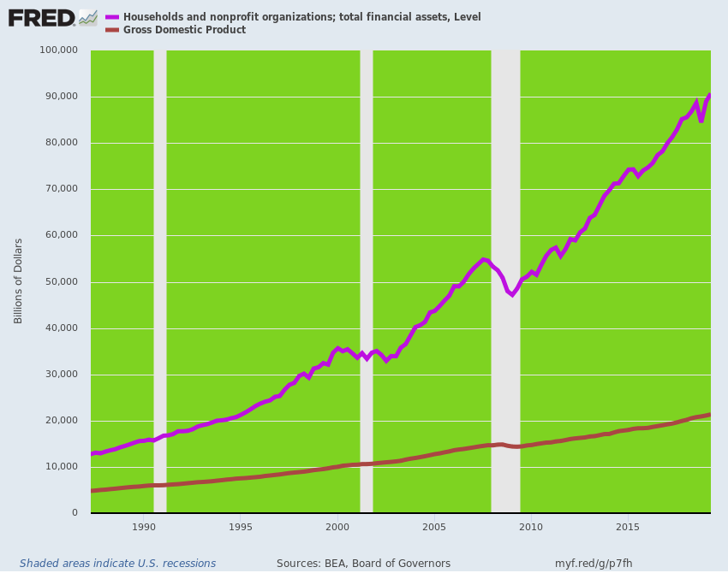
And we do mean "gift". After all, the US economy is on an unmistakable downward trajectory of ever slower growth. And the chart below screens out all the short-term inventory fluctuations and cyclical dips and rips by tracking the 10-year rolling average rate of GDP growth.
The implication can not be gainsaid. A 10-year trend growth rate of 1.5%---and which is likely heading lower after the impending recession quarters are rolled in during the early 2020s---should be capitalized at a lower multiple than was the pre-Greenspan economic growth rate of 3.0% to 4.5% per annum, not a sharply higher one.
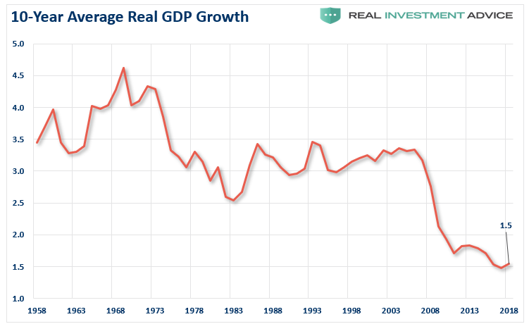
Moreover, and for want of doubt, the above displayed inflation of the capitalization rate did not begin until after Greenspan took the helm at the Fed in August 1987.
Accordingly, during the heyday of American prosperity between 1955 and 1987, the ratio of household financial assets to GDP remained fixed at its historic level of 2.7X; it only erupted to current nosebleed levels in the decades thereafter:
- 1955 = 2.7X;
- 1987 = 2.7X;
- 2007 =3.8X;
- 2019= 4.3X
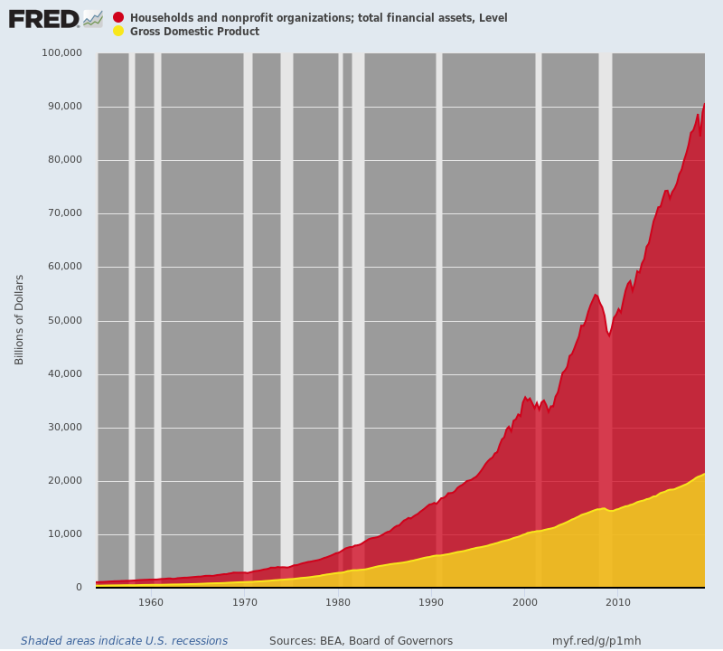
Indeed, after 30 Years of Keynesian central banking, financial asset values have been so hideously inflated that they bear no relationship at all to the Main Street fundamentals.
The chart below covers total household net worth----including tangible assets and housing, net of liabilities.
Compared to a
- 350% average ratio between 1952 and 1987, the ratio soared to
- 450% at the dotcom bubble peak and then hit
- 486% at the housing bubble peak in 2007-2008. But the Fed was not remotely done, of course. After reflating the financial system with malice aforethought since the 2008 crisis, it has succeeded in ballooning the aggregate net worth of America's 127.5 million households to an off-the-charts
- 535% of GDP.
So the question recurs: Who in their right mind could believe that a national economy which is a shadow of its former self in terms of the trend growth rate of output, income and profits should generate household net worth that is nearly 55% greater relative to GDP than it was in the heyday?
Needless to say, the "who" in question includes the 12 knuckleheads who comprise the FOMC. The latter insist their handiwork---especially since the Great Recession---has produced no bubbles or financial imbalances. That is, they refuse to even believe their own lying eyes.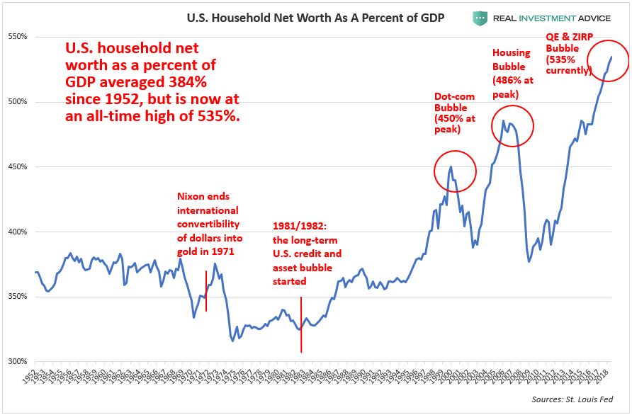
The Wall Street perma-bulls, of course, are want to say that this uncoupling of household net worth from national income is owing to a huge gains in corporate profits, which get capitalized in stock market values.
But that cover story doesn't hold water, either. Pre-tax corporate profits of $1.9 trillion in Q3 2006 inched upwards to $2.08 trillion in Q2 2019, representing a meager gain of 0.73% per annum.
By contrast, nominal GDP grew from $13.9 trillion to $21.3 trillion during that 13-year period. The 3.4% rate of nominal GDP growth, therefore, indicates that the pre-tax profits share of GDP actually fell---even as the household net worth ratio continued to climb skyward.
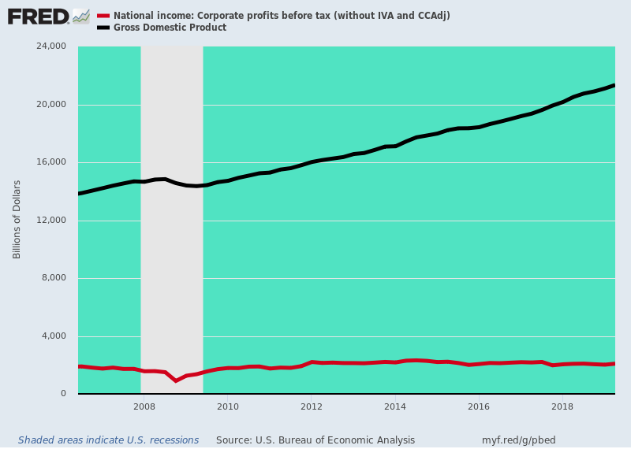

And that gets us to Pocahontas. The Elizabeth Warren Express is clearly pulling out of the station, and as a political matter her wealth tax is the sleeper issue of the 2020 election by our lights.
To wit, when the market plunges and the next C-suite initiated spree of lay-offs, write-downs and restructuring plans hits the headlines----and this will surely happen before November 2020---billionaires and the super-rich will be in the political cross hairs; and in that context, the wealth tax as an instrument of condign justice---to say nothing of easy revenue to pay for all her free stuff---will resonant powerfully.
That's because three decades of central bank asset inflation has skewed wealth artificially and radically to the tippy-top of the economic ladder. The math permits no other outcome, in fact, given that the top 1% own well more than 40% of the financial assets.
Accordingly, the wealth maldistribution has reached hideous levels owing to the massive and persistent inflation of financial assets by the post-1987 regime of Keynesian central banking.
- The Net Worth of Top 1% Went From $1.5 trillion in 1972 to $46 Trillion in 2019
- The Top 1% Share Went From 34% in 1972 to 40% in 2019;
- The Bottom 90% Net Worth Is Just $29 Trillion; Share is Down From 34% to 21%
- Wealth Tax Is A Political Winner Unlike Income Tax Increases Which Scare 95 Million Payers
- Only 600 Billionaires In US; 83,500 Households (o.07%) Above $50 Million Net Worth
.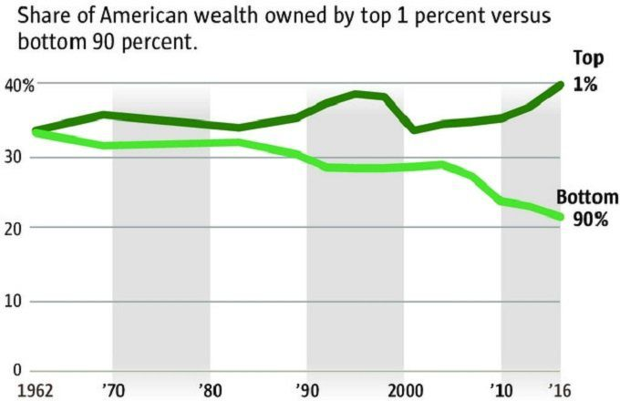
As we indicated above, unlike past liberal soak-the-rich income tax schemes which frighten the 170 million income tax filers and the 95 million who actually pay, the Warren wealth tax is positioned so high up in the wealth tree-tops that we believe it is likely to be immune to the GOP demogouery that will attend to the Trump v. Warren general election campaign.
After all, the top 0.1% of US households will pay the entire $2.4 trillion of wealth tax collections projected over the decade after enactment. Indeed, the 83,500 households eligible for the Warren wealth tax constitute only 0.07% of America's 127.5 million household units.
So not even all of the 0.1% (127,500 households) will be subject to Warren's net worth scalping. As it happens, therefore, the targets of the Warren wealth tax also account for roughly 0.07% of the likely 135 million voters in 2020, as well.
Needless to say, the wealth skew to the tippy-top since 1987 has been startling. As designated by the vertical arrow, the bottom 90% of households' share of national wealth peaked at a 36% and has plunged to 22% since then.
And all of that loss went to the top 0.1%---a fact of life in Flyover America that is felt, even if not statistically understood.
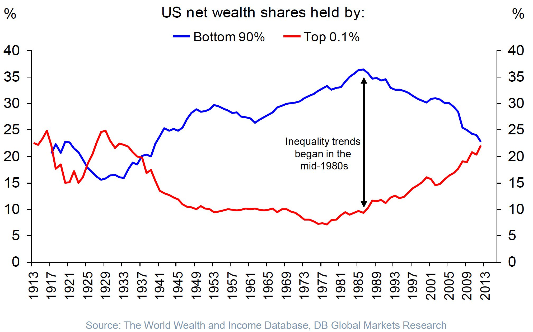
Having sown the seeds of the Warren Express, the central bankers were enthusiastically in the reverse-Robin Hood business again this morning to the tune of an $82.5 billion gift to the 1% and the 0.1%, especially.
We are referring to the $75 billion of repo cash injected into Wall Street this AM by the Fed, along with the $7.5 billion of Treasury bills it purchased under the first outing of its "not QE-4"
As Lee Adler noted, we are fast heading for another $900 billion injection of fiat credit into the canyons of Wall Street. Contrary to all the claims when the repo facility was put into place last month, there is nothing temporary about it:
In yesterday's Fed Temporary Open Market Operations, the dealers took $20 billion in 14 day term repos and $67.6 billion in overnight repos for a total take of $87.7 billion. $61.5 billion expired. Therefore, the net increase was $26.2 billion in Fed repos outstanding, bringing the total to $190.3 billion.
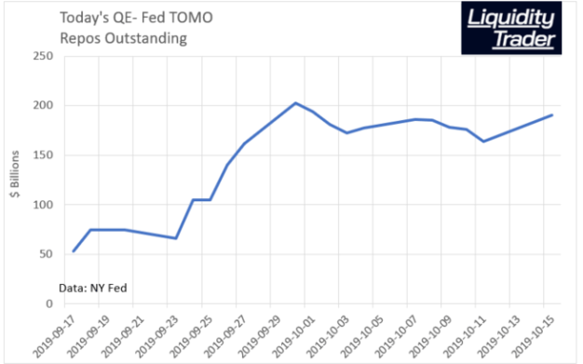
When you layer on top of that another $720 billion of annualized treasury bill purchases---which started with this morning's initial $7.5 billion installment---you are off to the races.
A Sven Heinrich noted, they may not call it QE, but $720 billion ain't chicken feed:
You know what else is $720B a year or $60B a month? The ENTIRE US MILITARY BUDGET. The largest military budget on the planet.
- Millions under arms,
- submarines,
- aircraft carriers,
- nuclear arsenal,
- bombers,
- fighter jets,
- military bases across the globe,
- satellites,
- drones,
- laser guided missiles,
you name it. All of it runs at $60B per month.
So lest everyone is blind to numbers these days as everything is so monstrous our eyes glaze over I trust this comparison highlights how massive the Fed’s announcement was on Friday. But not QE. Right. Believe it if you so choose.
Yet these knuckleheads pretend that massive injection of fiat demand into the financial asset markets is just a technical step called "reserve management".
Puleese!
The narrative of the Fed heads has become downright risible.....embarrassing in its blatant dishonesty even.
I want to emphasize that growth of our balance sheet for reserve management purposes should in no way be confused with the large-scale asset purchase programs that we deployed after the financial crisis. Neither the recent technical issues nor the purchases of Treasury bills we are contemplating to resolve them should materially affect the stance of monetary policy. In no sense, is this QE,” – Jerome Powell
Right! It's QE by any other name.
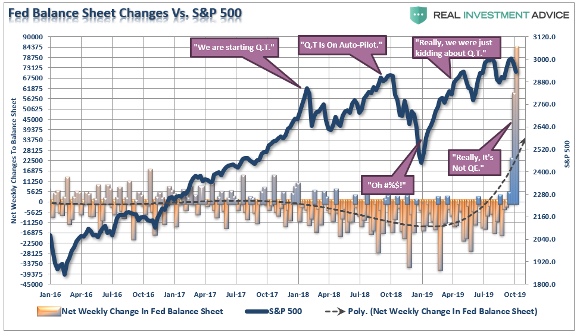
And why are they restarting this monetary lunacy?
You don't have to look very far for the answer. As we noted last week, during the last quarter of FY 2019 ending on September 30, Uncle Sam dumped more than $600 billion of new Federal debt into the bond pits to fund the Donald's soaring deficits.
That caused, in turn, the balance sheets of the 24 dealers to explode and their demand for repo financing to soar. Yet the FOMC's maniacal commitment to interest rate targeting to the second decimal place---currently at the absurdly low fed funds rate of 1.75%----has led it to pump fiat credit into the canyons of Wall Street at a $900 billion annual rate in order to force the money markets to obey it's writ.

We have known for many months that this was coming, as the banks funded virtually all of their Treasury purchases with repo borrowing since 2017. Treasury issuance soared as the budget deficit grew. Dealers and their parent and client banks bought more and more. Repo borrowing soared.
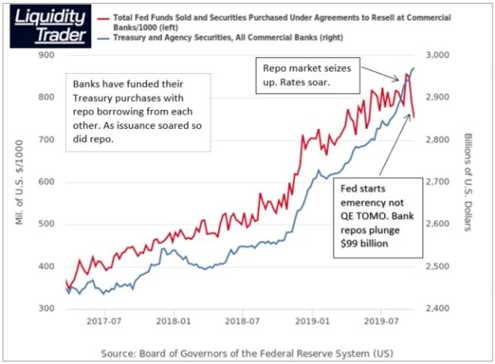
Whether this desperate gambit could keep the bubble aloft at this late stage of the cycle would ordinarily remain to be seen.
Not this time, however.
Here comes the Elizabeth Warren Express and the faster it picks up speed, the more certain that the Greatest financial bubble ever will reach its sell-by date before November 2020.
[Spinning the above out a bit, Stockman seem to be watching for something like the following, as of late summer 2020.
Via the Elizabeth Warren candidacy, the notion of implementing a Robin Hood approach to implement Medicare for all, continuing DoD expenditures over a Trillion $ per year (counting everything), serious action to lessen Global Warming, et al.,
all without hyperinflating Main Street has become plausible, as is her winning the election.
The implication of that is that the angry red area in the third chart from the beginning, above, will start to increase less per year implying a massive panicy implosion in at least some financial asset classes !!! 1929-1932 will look trivial by comparison! -FNC]

